**Team 21 - BashGuardians - PartyGuardiOS**

**Client Name: Jacob Stansbury**

**Team member roles & responsibilities**

Spandana - S524987 - Primary Contact  
Pushpak - S525004 - Issues Management  
Vinod - S525117 - Communications and Documentation Management  
Yashwanth - S525056 - Quality and Testing Management  
Nandeesh - S525120 - Requirements Management  
Naveen - S525051 - Data Management  
Sanjeev - S525034 - Client Management

**What our team finished:**

1. **Requirement Discovery**

**Week1:**

* Worked on received prototype for both host/guard user and basic user screens.
* Link for Basic User prototypes: [https://projects.invisionapp.com/share/SB76VFTTR#/screens (Links to an external site.) (Links to an external site.)](https://projects.invisionapp.com/share/SB76VFTTR#/screens)
* Link for Host/Guard User Prototypes: [https://projects.invisionapp.com/share/EN7YELSSH#/screens (Links to an external site.) (Links to an external site.)](https://projects.invisionapp.com/share/EN7YELSSH#/screens)

**Week2:**

* We have grabbed the components required for our project such as Mac Book and iPad from the library.
* We need to acquire some more requirements such as application logo, label constraints and remaining design specifications from the client.

**Week3:**

* We grabbed the designs given by the client to design user interfaces for Situation, Location and Alert screens.
* We need to collaborate with team Invincible techies (Team number: 54) and prepare for the client demo1.

**Week4:**

* We grabbed the designs given by the client to design user interfaces for guard user login screen
* We are preparing Presentation of issue management for this Monday.

**Week5:**

* With the help of the designs given by the client, we have tried to implement the same with functionalities and developing them according to the requirements.
* We have to collaborate with the services team and have to present a demo on the progress since the last demo.

**Design Creation/Modification**

**Week1:**

* Completed UI Design for login and signup screens

**Week2:**

* Completed UI Design for App information page and Fraternity list screens

**Week3:**

* Completed integrating three view controllers of basic user & host user login screen, user registration, App information guide screen.
* Completed preparation for the client demo1.

**Week4:**

* Completed creating the guard user interface for the app and tested the screens.
* Started preparation for the client demo2.

**Week5:**

* Completed 50% of the interfaces and started testing them after developing the screens along with coding.
* Preparing for client demo2.

1. **Development of Application**

* We started developing the fraternities list screen, Party Guard team screen and also all the basic screens like login and registration.

1. **Client Interaction**

* We have interacted with the client.
* Need to acquire the client approval for the work we did until now.

1. **Testing**

**Week1:**

* Didn’t receive iPad and Mac Book.

**Week2:**

* Used iPad for testing the designed user interfaces for login, signup, app information and fraternity list screens.

**Week3:**

* Used iPad for test the user interfaces login, signup, app information and fraternity list screens we designed and the transition between them.

**Week4:**

* Used iPad for test the user interfaces for the appropriate values for the fields like accepting only numbers for phone number and allowing only people above the age of 21 to register.

**Week5:**

* Used iPad for testing the UI developed and also all the validations to be performed on all the fileds.

1. **Documentation**

We have written the code and pushed to the bitbucket and explained the procedure.

**Screenshots of major artifacts for accomplishments:**

* As we collaborated with another PartyGuard team Invincible techies (Team number: 54) we are going to present the screen shots of our recent work. They are as follows:

**1) Basic user login**

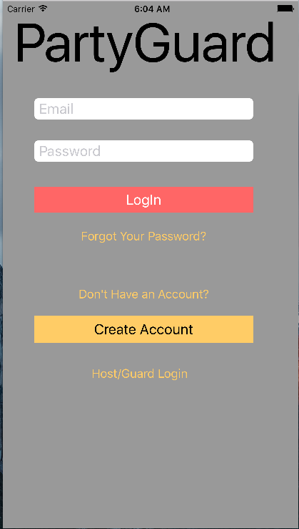

**2) Registration screen**

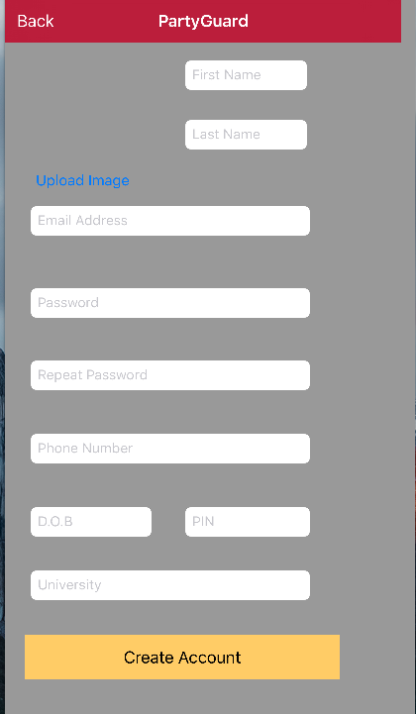

**3) App Information**

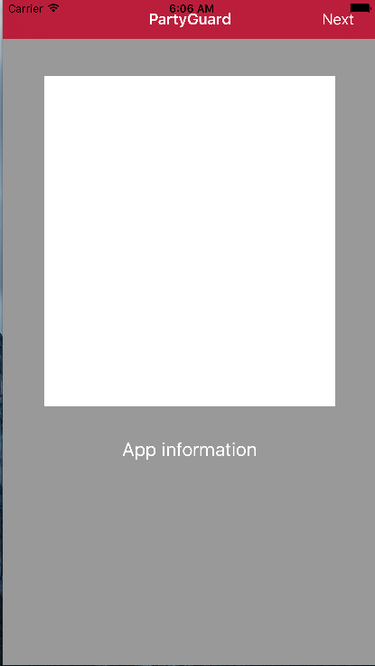

**4) Fraternities**

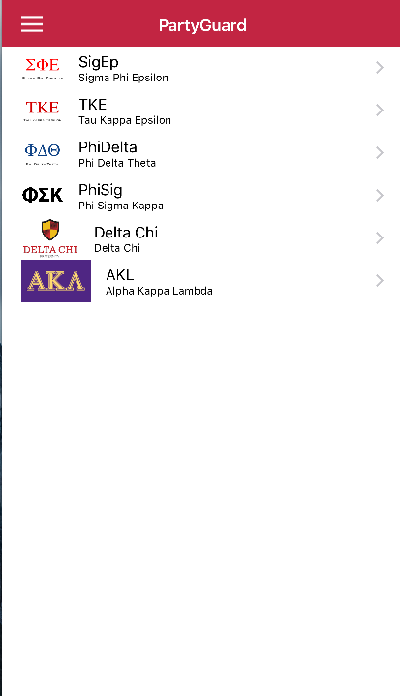

**5) Profile**

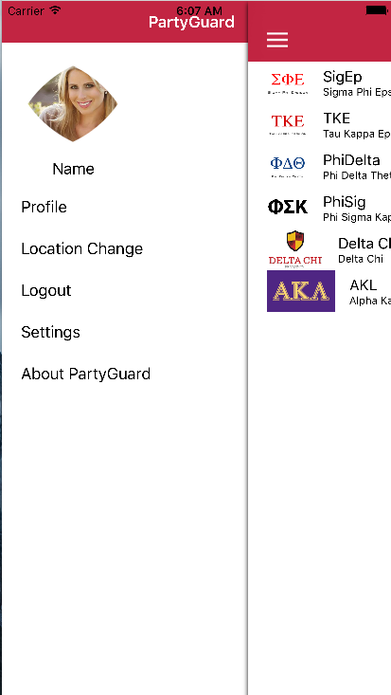

**6)Incidents**

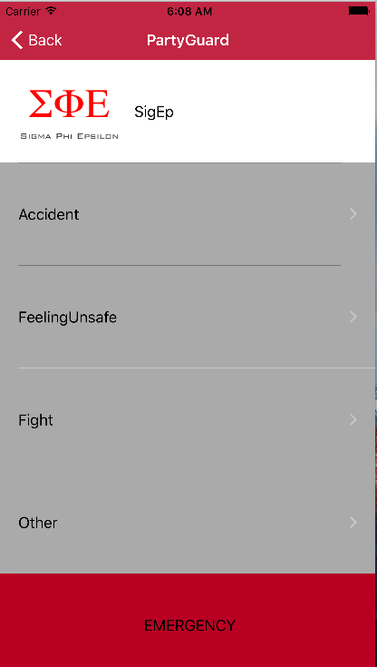

**7) options for various incidents**

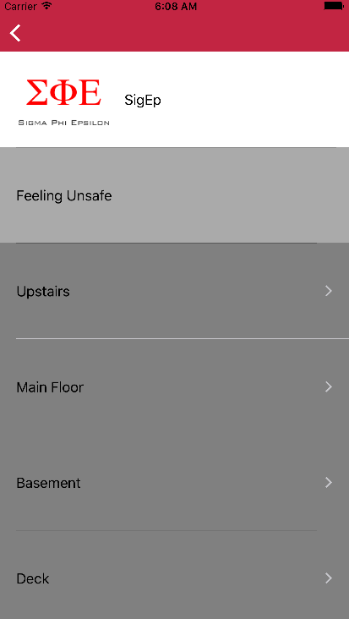

**8) Alert Confirmation**

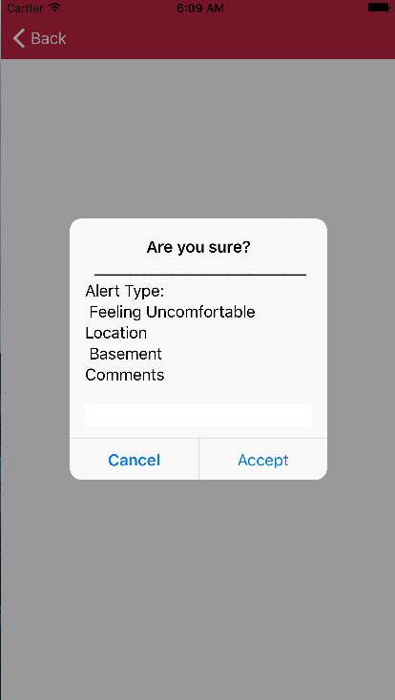

**9) Guard assistance**

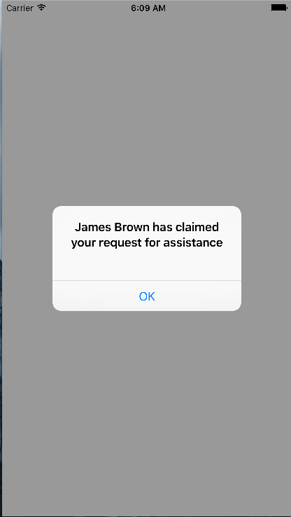

**10)** **guard user confirmation**

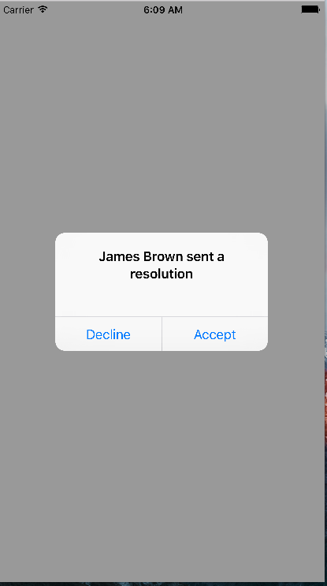

**11) Invalid login screen**

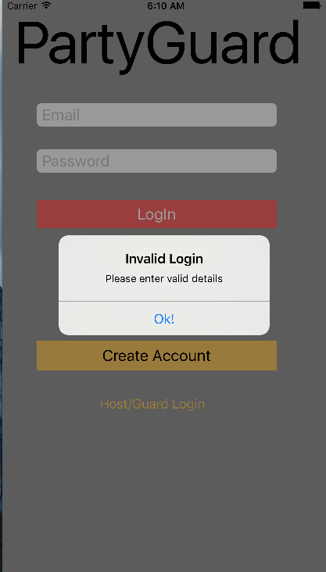

**12) Guard user login**

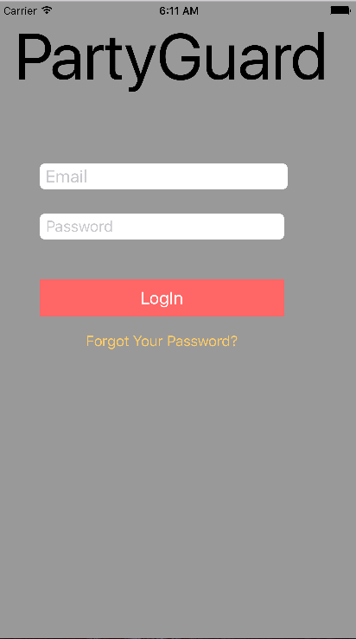

**13) list of guard users**

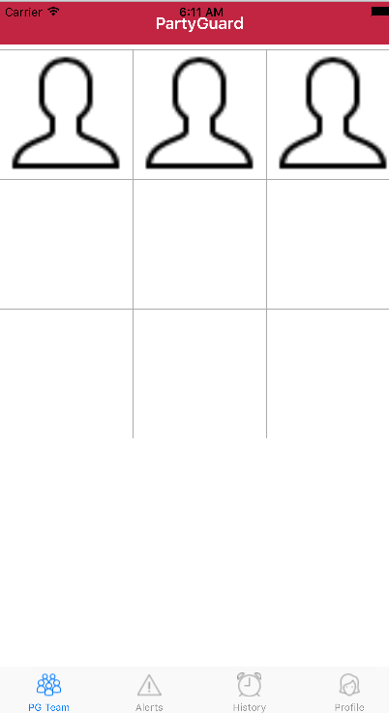

**14) screen to reset your password**

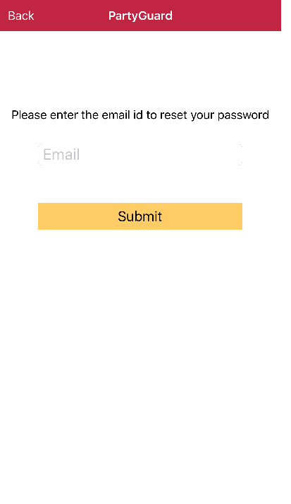

**15) list of requests from basic user**

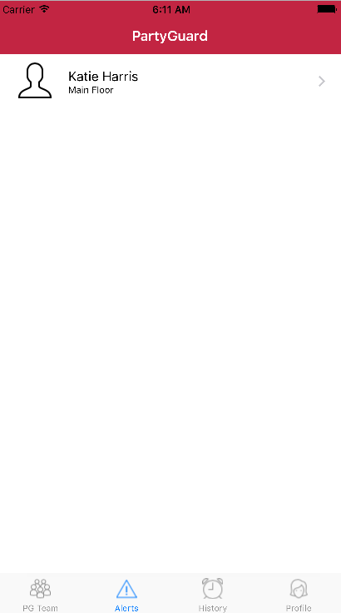

**17)page to reset profile**

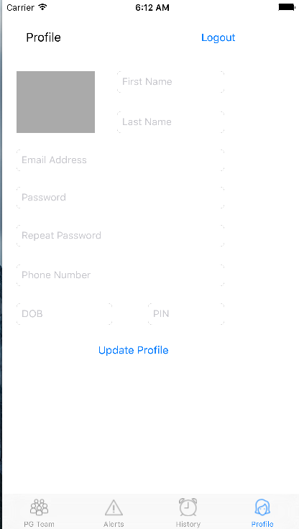

**Link for Repository:** [https://bitbucket.org/bashguardians/bashguardians (Links to an external site.) (Links to an external site.)](https://bitbucket.org/bashguardians/bashguardians)

Person responsible:

Vinod, Nandeesh, Yashwanth, and Pushpak – UI Design of login and signup screens

Sanjeev, Naveen, and Spandana – UI Design of App information and Fraternity list screens

Team Bash Guardians – M01

Vinod and Nandeesh – F01

Sanjeev – GDP 1 Project Manager Briefing

Yashwanth and Sanjeev – GDP 1 Presentation

Team Bash Guardians – M02

Sanjeev and Naveen – F02

Team Bash Guardians – M03

Sai spandana Chava –F05

**Work in progress:**

* Designing user interfaces for guard user screen, Party Guard team screen and testing.
* Working on Issue Management presentation.

Person responsible:

Sanjeev and Naveen – Location, Situation and Menu screens (8 hours)

Vinod and Nandeesh – Host/Guard user screens (6 hours)

Yashwanth, Pushpak, and Spandana – Alert screens for both host/guard user and basic user (8 hours)

Team Bash Guardians – client2 demo presentation (6 hours)

Sanjeev, Naveen, Spandana – Developing App information screen (4 hours)

Vinod, Nandeesh, Pushpak, Yashwanth – Developing login and signup screens (4 hours)

**Link for Trello Board:**[**https://trello.com/b/p8DPSe0J/partyguard-ios-bash-guardians (Links to an external site.) (Links to an external site.)**](https://trello.com/b/p8DPSe0J/partyguard-ios-bash-guardians)